**

### Semester 1 Examination 2011

### Question/Answer Booklet

**MATHEMATICS**

Please place your student identification label in this box

**SPECIALIST 3C/3D**

**Section One:**

**Calculator-free**

Student Number: In figures

In words

**Time allowed for this section**

Reading time before commencing work: 5 minutes

Working time for this section: 50 minutes

**Materials required/recommended for this section**

***To be provided by the supervisor***

This Question/Answer Booklet

Formula Sheet

***To be provided by the candidate***

Standard items: pens, pencils, pencil sharpener, eraser, correction fluid, ruler, highlighters

Special items: nil

**Important note to candidates**

No other items may be used in this section of the examination. It is **your** responsibility to ensure that you do not have any unauthorised notes or other items of a non-personal nature in the examination room. If you have any unauthorised material with you, hand it to the supervisor **before** reading any further.

**Structure of this paper**

|  |  |  |  |  |
| --- | --- | --- | --- | --- |
| Section | Number of questions available | Number of questions to be answered | Working time (minutes) | Marks  available |
| **Section One:**  **Calculator-free** | **6** | **6** | **50** | **40** |
| Section Two:  Calculator-assumed | 10 | 10 | 100 | 80 |
|  |  |  |  | 120 |

**Instructions to candidates**

1. The rules for the conduct of Trinity College examinations are detailed in the *College Diary*. Sitting this examination implies that you agree to abide by these rules.

2. Write your answers in the spaces provided in this Question/Answer Booklet. Spare pages are included at the end of this booklet. They can be used for planning your responses and/or as additional space if required to continue an answer.

* + Planning: If you use the spare pages for planning, indicate this clearly at the top of the page.
  + Continuing an answer: If you need to use the space to continue an answer, indicate in the original answer space where the answer is continued, i.e. give the page number. Fill in the number of the question(s) that you are continuing to answer at the top of the page.

3. **Show all your working clearly.** Your working should be in sufficient detail to allow your answers to be checked readily and for marks to be awarded for reasoning. Incorrect answers given without supporting reasoning cannot be allocated any marks. For any question or part question worth more than two marks, valid working or justification is required to receive full marks. If you repeat an answer to any question, ensure that you cancel the answer you do not wish to have marked.

4. It is recommended that you **do not use pencil** except in diagrams.

1. (6 marks)

Given the matrices B =  and C = 

(a) (i) Determine the matrix **A** such that **A** = **BC** [2]

(ii) Determine the matrix **D** such that **D**-1 = **B** [2]

The matrix **E** = 

(b) Determine the value(s) of *r* for which the matrix **E** is singular. [2]

2. (9 marks)

Let , , and  . Express the following in exact polar form:

(a)  [2]

(b)  [1]

(c)  [3]

(d)  [3]

3. (8 marks)

(a) Solve  expressing your answer(s) in polar form. [4]

(b) Sketch your solutions to part (a) on an Argand diagram. [2]

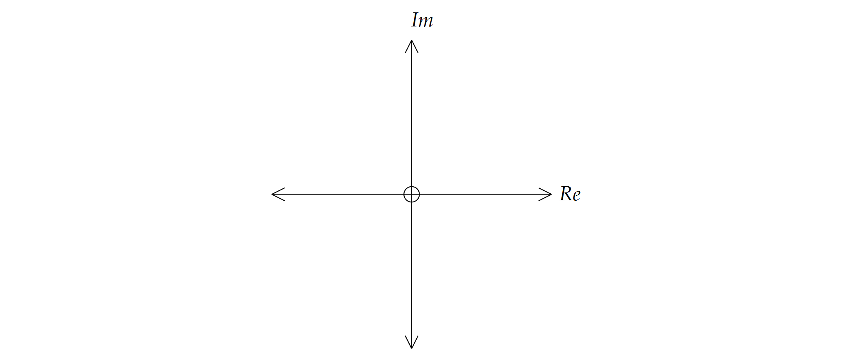

(c) What is the sum of the three roots found in part (a)? [2]

4. (8 marks)

Let 

(a) Write *f(x)* in piecewise form [3]

(b) Sketch *y = f(x)* [3]

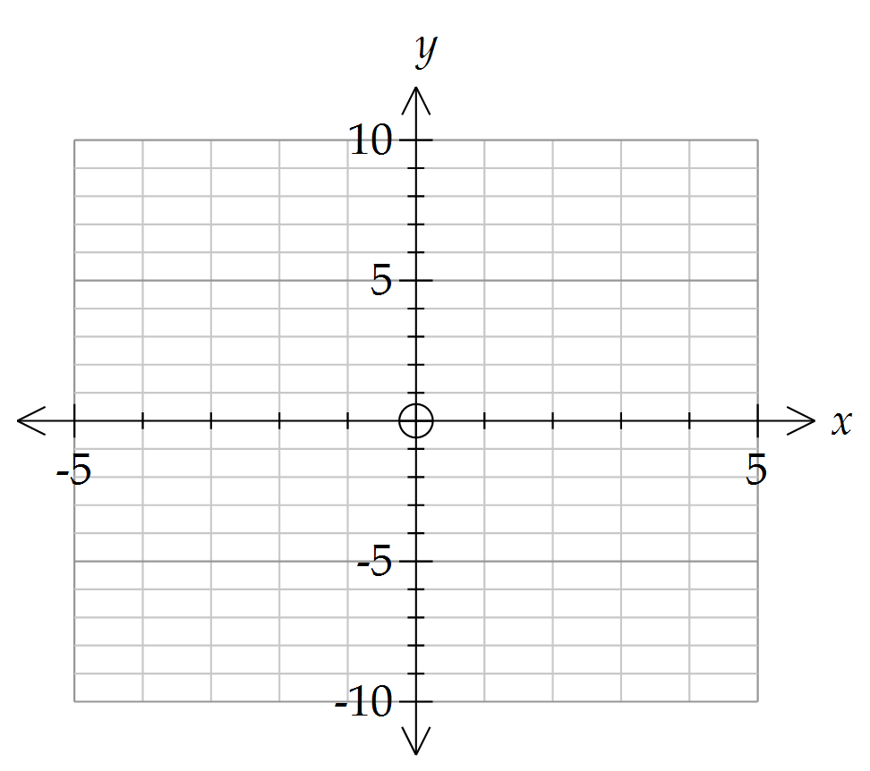

(c) Solve  [2]

5. (4 marks)

(a) Below is the graph of  . On the same axes, draw a graph of 

[3]

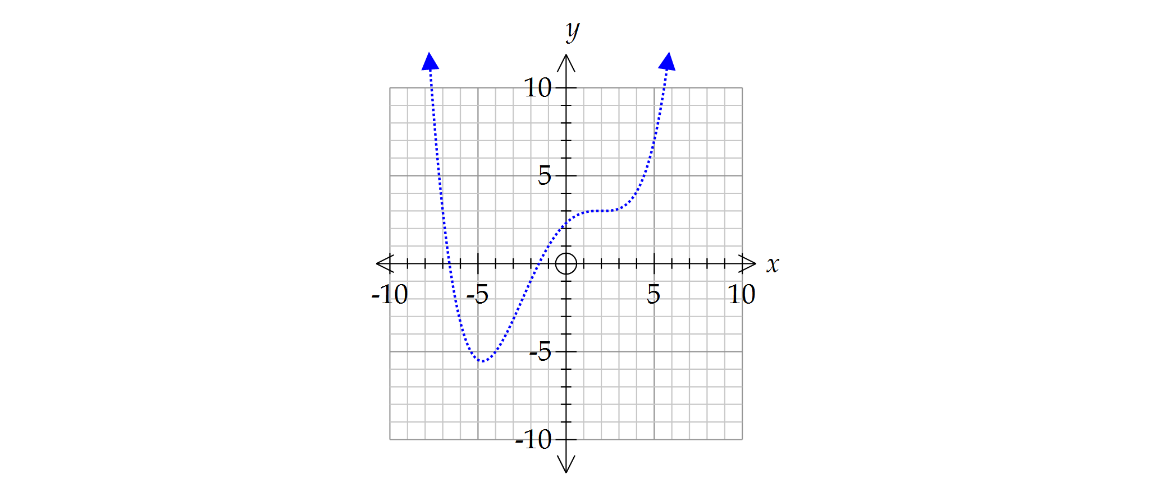

(b) Describe geometrically how  differs from  [1]

6. (5 marks)

Let  and suppose that 

Show that:  where k is an integer

**Additional working space**

Question number(s): ……………………

**Additional working space**

Question number(s): ……………………

**Additional working space**

Question number(s): ……………………

**

### Semester 1 Examination 2011

### Question/Answer Booklet

Please place your student identification label in this box

**MATHEMATICS**

**SPECIALIST 3C/3D**

**Section Two:**

**Calculator-assumed**

Student Number: In figures

In words

**Time allowed for this section**

Reading time before commencing work: 10 minutes

Working time for this section: 100 minutes

**Material required/recommended for this section**

***To be provided by the supervisor***

This Question/Answer Booklet

Formula Sheet (retained from Section One)

***To be provided by the candidate***

Standard items: pens, pencils, pencil sharpener, eraser, correction fluid, ruler, highlighters

Special items: drawing instruments, templates, notes on two unfolded sheets of A4 paper, and up to three calculators satisfying the conditions set by the Curriculum Council for this course.

**Important note to candidates**

No other items may be taken into the examination room. It is **your** responsibility to ensure that you do not have any unauthorised notes or other items of a non-personal nature in the examination room. If you have any unauthorised material with you, hand it to the supervisor **before** reading any further.

**Structure of this paper**

|  |  |  |  |  |
| --- | --- | --- | --- | --- |
| Section | Number of questions available | Number of questions to be answered | Working time (minutes) | Marks available |
| Section One:  Calculator-free | 6 | 6 | 50 | 40 |
| **Section Two:**  **Calculator-assumed** | **10** | **10** | **100** | **80** |
|  |  |  |  | 120 |

**Instructions to candidates**

1. The rules for the conduct of Trinity College examinations are detailed in the *College Diary*. Sitting this examination implies that you agree to abide by these rules.

2. Write your answers in the spaces provided in this Question/Answer Booklet. Spare pages are included at the end of this booklet. They can be used for planning your responses and/or as additional space if required to continue an answer.

* + Planning: If you use the spare pages for planning, indicate this clearly at the top of the page.
  + Continuing an answer: If you need to use the space to continue an answer, indicate in the original answer space where the answer is continued, i.e. give the page number. Fill in the number of the question(s) that you are continuing to answer at the top of the page.

3. **Show all your working clearly.** Your working should be in sufficient detail to allow your answers to be checked readily and for marks to be awarded for reasoning. Incorrect answers given without supporting reasoning cannot be allocated any marks. For any question or part question worth more than two marks, valid working or justification is required to receive full marks. If you repeat an answer to any question, ensure that you cancel the answer you do not wish to have marked.

4. It is recommended that you **do not use pencil** except in diagrams.

7. (10 marks)

Given the points M, N and P with position vectors **m** = 2**i** + 3**j** – 4**k**, **n** = -3**i** + 2**j** + 2**k** and **p** = 3**i** – **k** respectively, determine:

(a) 2**m** – 3**p** [2]

(b) |**n**|as an exact value [1]

(c) a unit vector parallel to **n** [1]

(d) the angle, to the nearest degree, that **n** makes with the positive z-axis. [2]

(e) the distance between M and N [2]

(f) the value of  such that  is perpendicular to **m**. [2]

8. (6 marks)

Consider the following polar graph:

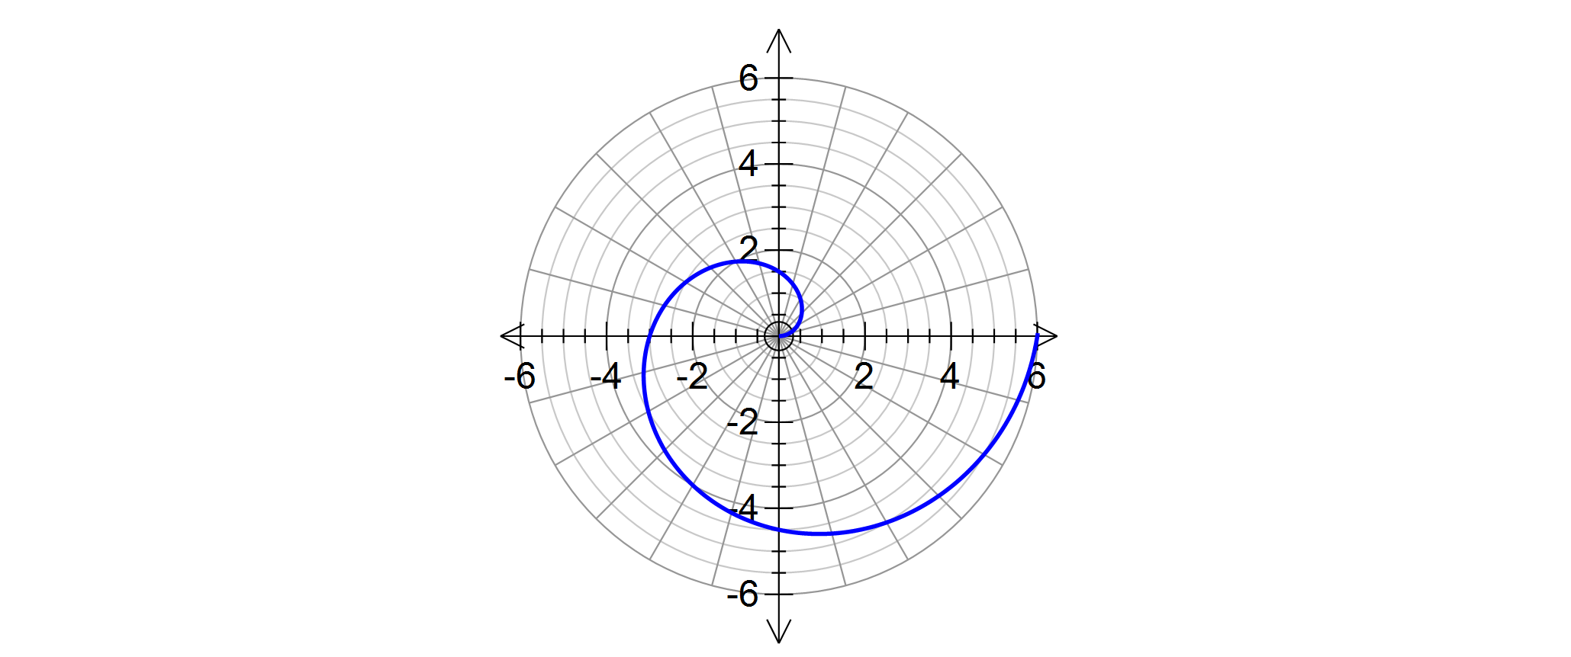

(a) Determine the equation of the spiral. [2]

(b) Determine the polar coordinate of the point of intersection of the spiral with a circle of radius 2. [2]

(c) Determine the exact distance between the point found in (b) and the end point of the spiral. [2]

9. (9 marks)

Triangle ABC has vertices A(0, 0), B(2, 2), C(2, 0).

(a) Determine the image of ABC under the transformation, indicating clearly the new vertices A', B' and C'. [3]

(b) Let A"B"C" be a triangle with vertices A"(0,0), B"(6, 4), C"(0, 4). Describe geometrically the transformations that map ABC onto A"B"C".

[Hint: Draw a sketch of the two triangles.] [3]

(c) Hence or otherwise, determine the transformation matrix M that maps ABC onto A"B"C". [3]

10. (8 marks)

(a) Describe the following region in the Argand plane [2]

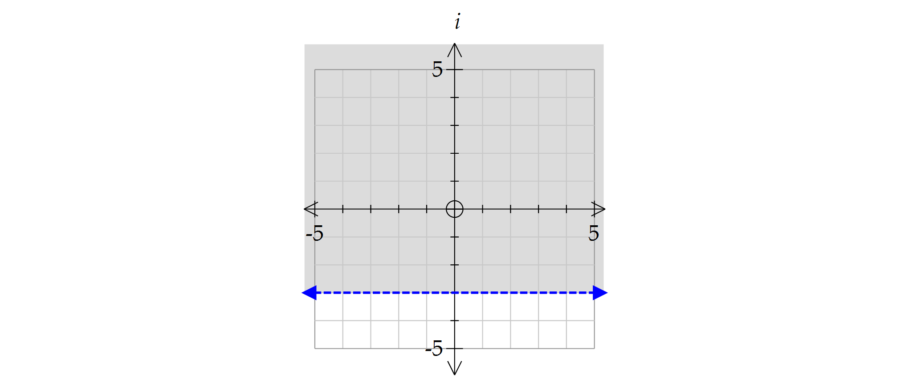

(b) Sketch the following sets of points in the Argand plane.

(i)  [3]

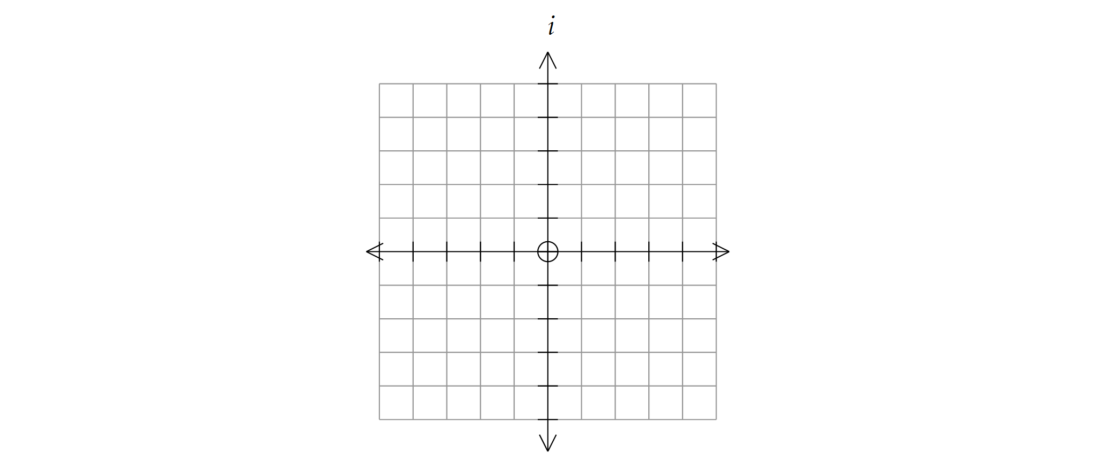

(ii)  [3]



11. (5 marks)

The matrix P is non-singular and it can be shown that **P** + **P** =  . Also, it is known that **P**= 

Determine the matrix **P**

12. (10 marks)

Scientists in the tropics studied the changes in a colony of a new species of slater. Their observations of female slaters indicate that:

* of the female newborn slaters survive to be 1 month old
* of the female 1-month-olds survive to be 2 months old
* Only the 2-month-old females give birth to eight female newborns
* Female slaters survive for 3 months, at most.

(a) Represent this information in a Leslie matrix. [2]

The column matrix  represents the initial female population of the colony:



(b) How many newborn female slaters in this colony will survive to be 1 month old? [1]

(c) Determine the percentage change in the total female slater population after one month. [2]

(d) Determine the percentage change in the total female slater population after three months compared with the initial population of this colony. Describe what this result represents? [3]

(f) In the long term, describe the growth of this population. [2]

13. (12 marks)

A hot air balloon takes off 20 km north of a country town called York. The velocity of the balloon is given by the vector 5**i** – 16**j** + 2**k** km/hr, where the vectors **i**, **j** and **k** are unit vectors in the direction east, north and vertically upward respectively.

(a) Write down the initial position vector of the balloon. [1]

(b) Write down the position vector of the balloon after 30 minutes. [2]

(c) Determine the speed at which the balloon is moving. [2]

(d) Determine the angle of ascent of the balloon. [2]

A second balloon takes off from the centre of the town of York with velocity given by the vector 5**i** – 10**j** +1.8**k** km/hr

(e) (i) If both balloons leave the ground at 6 am, at what time will the two balloons be closest to each other? Give your answer to the nearest minute. [4]

(ii) What is the closest distance between the two balloons? Give your answer to the nearest metre. [1]

14. (8 marks)

(a) Determine, in parametric form, the equation of the line containing the two points (5, -4, 6) and (-7, 12, 2). [3]

(b) Determine the point at which the line found in part (a) intersects the plane  [3]

(c) Determine the equation of the plane perpendicular to the line found in part (a) that passes through the point of intersection found in part (b). [2]

15. (6 marks)

An equilateral triangle has vertices *P*, *Q* and *R* where *P* is the point  in the Argand plane. The centre of the triangle is located at the origin. Determine the complex numbers representing *Q* and *R*, expressing your answers in Cartesian form.

16. (6 marks)

Let  be a complex number.

It is given that the quotient  is purely imaginary.

Show that *z* lies on a circle and determine the centre and radius of this circle.

**END OF EXAMINATION**

**Additional working space**

Question number(s): ……………………

**Additional working space**

Question number(s): ……………………